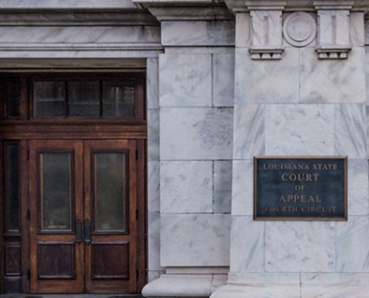
Welcome, And Thank You for Visiting the Court of Appeal for the Fourth Circuit’s History and Information Page.

The Court of Appeal for the Fourth Circuit, State of Louisiana (“Fourth Circuit”).

Located in the heart of New Orleans Central Business District, the Fourth Circuit is an intermediate appellate court that serves the citizens of St. Bernard, Plaquemines, and Orleans parishes in the great state of Louisiana.

The Fourth Circuit Court of Appeal began as the Court of Appeals for the Parish of Orleans, created by Art.128 of the Louisiana Constitution of 1879. Louisiana’s Constitution also created five Courts of Appeal circuits for the remaining parishes. Each circuit had two judges. Art. 131 of the Louisiana Constitution of 1898 increased the number of judges to three and added the parishes of Jefferson, St. Charles, Plaquemines, and St. Bernard to the court’s jurisdiction, to begin on August 1, 1900. Act. No. 137 of 1906 added St. James and St. John the Baptist to its jurisdiction.
The courts of appeal were realigned in 1958 when the Constitution of 1921 was amended, effective July 1, 1960, and the court became the new Court of Appeal, Fourth Circuit, State of Louisiana. Act. No. 696 of 1968 increased the number of judges to nine. Act. No. 661 of 1980 created the Fifth Circuit and gave it several parishes from the court’s territory. The Fourth Circuit retained the parishes of Orleans, Plaquemines, and St. Bernard and gained an extra judgeship. Act. No. 3 of 1981 increased the number of judges to twelve.
The old Court of Appeals for the Parish of Orleans was located on the second floor of the Presbytere, on the corner of Chartres and St. Ann Streets. In 1910, the court moved into the new Civil District Court Building at 400 Royal Street. In 1959, the court moved to the Civil Court Building at 421 Loyola Avenue, which was a part of the newly constructed government complex for the city of New Orleans. Some judges were housed at the 234 Loyola Building where other state office were located. In 1990, as Orleans Parish Civil District and Juvenile courts grew, the court moved to 1515 Poydras Street, 7th Floor. In 2004, after an extensive historic restoration, the court returned to its old home at 400 Royal Street.
Judges of all Louisiana Circuit Courts of Appeal are elected in partisan elections. To be qualified to serve, you must be a resident of the respective circuit for at least one year and licensed to practice law in the state of Louisiana for at least ten years.

Chief Judges
On each of the five Louisiana appellate courts, the Judge who has served the longest is named the Chief Judge. The current Chief Judge for the Fourth Circuit is the Honorable Terri F. Love. Chief Judge Love began her tenure as a Judge on the Fourth Circuit in September 2000.
There have been eighteen Chief Judges for the Fourth Circuit Court of Appeal State of Louisiana since the Court was established in 1960.
List of Former Chief Judges of the Fourth Circuit Court of Appeal
Chief Judge James F. McKay III
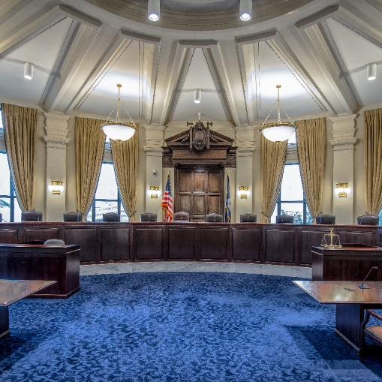
Chief Judge Charles R. Jones
Chief Judge Joan Bernard Armstrong
Chief Judge William H. Byrnes
Chief Judge Robert J. Klees
Chief Judge Denis A. Barry
Chief Judge Patrick M. Schott
Chief Judge James C. Gulotta
Chief Judge Julian L. Samuel
Chief Judge William V. Redmann
Chief Judge Frank McGloin
Chief Judge Albert Estopinal
Chief Judge Charles F. Claiborne
Chief Judge William W. Westerfield
Chief Judge George Janvier
Chief Judge Richard T. McBride
Chief Judge Godfrey Z. Regan

Summary of the Appellate Practice Process

The Louisiana courts of appeal are vested with supervisory jurisdiction over cases that arise within their respective circuits. (La. Const. art. V, § 10(A); La.
Code Civ. Proc. Ann. art. 2083 cmt. a; La. Code Civ. Proc. Ann. art. 2201.)
A Louisiana court of appeal may grant a writ where either:
• The failure to grant a writ would result in irreparable injury.
• The following are true:
- the trial court’s decision is incorrect;
- there is no dispute of fact to be resolved; and
- a reversal will end the litigation.
(Herlitz Constr. Co., Inc. v. Hotel Inv’rs. of New Iberia, Inc., 396 So. 2d 878, 878 n.1 (La. 1981).)

A party may appeal as of right the following types of judgments from a trial court to a Louisiana court of appeal:
• A final judgment.
• Partial judgments that the trial courts designate final.
• A judgment reformed in connection with an additur or remittitur.
• An interlocutory judgment made expressly appealable by law.
(La. Code Civ. Proc. Ann. art. 2083.)
After the trial court issues its final judgment, a party or parties to the lawsuit who desires to appeal is required to file a motion for an appeal to the trial court and notice to the opposing counsel.
Mechanics of the Appellate Process
Each court of appeal has appellate jurisdiction over all civil matters, all matters appealed from family and juvenile courts, and all criminal cases triable by a jury that arises in its circuit, except for those cases appealable directly to the Supreme Court or to the district courts
Who Is Involved In An Appeal?
- The Appellant is a party to the original trial who disagrees with and seeks review of the trial court’s judgment in whole or in part. The Appellee is the opposing party responding to the appellant’s assertions, who may also seek a review of a portion of the trial court’s judgment. If the appeal request is granted, the trial court sends out a notice of appeal and prepares the record to be lodged with the Appellate court.
The Record Is Lodged
- Once the record is lodged with the Appellate court, the Clerk of the Court sends the parties’ notice of the briefing deadlines, dockets the appeal, and submits it to a three-judge panel. Each court sits in panels of at least three judges selected according to rules adopted by the court. A majority of the judges sitting in a case must concur to render judgment. However, in civil matters only, when a judgment of a district court or an administrative agency determination in a workers' compensation claim is to be modified or reversed and one judge dissents, the case must be argued before a panel of at least five judges prior to rendition the of judgment, and a majority must concur to render judgment. Cases can be heard en banc, meaning that all twelve judges will serve on the panel. One judge is designated as the “writer” of the case.
Legal Arguments
- The Appellant presents legal arguments to the panel, in writing, in a document called a "brief." In the brief, the appellant seeks to persuade the judges that the trial court made an error and that its decision should be reversed. On the other hand, the party defending against the appeal, known as the ‘appellee,’ presents legal arguments in its brief to support why the trial court’s decision was correct, or why any error made by the trial court was not significant enough to affect the outcome of the case. Parties may request an oral argument if desired.
Rulings

- Unlike a trial court, an appeals court does not issue judgments. Instead, the panel issues an opinion, which is a critique of the trial court’s judgment and contains the panel’s legal conclusions. The opinion can be issued as a unanimous opinion or with concurrences and dissents.

For questions about the Court’s History page, please email del@la4th.org.

The Law Library of Louisiana A Brief History of the Louisiana Courts of Appeal: Louisiana Court of Appeal, Fourth Circuit, Website: http://www.la4th.org/
The Law Library of Louisiana A Brief History of the Louisiana Courts of Appeal: Louisiana Court of Appeal, Fourth Circuit, Website: http://www.la4th.org/
Judicial Biography of Chief Judge Terri F. Love https://la4th.org/Default.aspx#judgesBio
Ballotpedia, Former Chief Judges, https://ballotpedia.org/Louisiana_Fourth_Circuit_Court_of_Appeal
Appeals | United States Courts (uscourts.gov)

